Functional Model
System Name: Parent–Child Daily Awareness System
By
Pavankumarreddy Alugubelly

1. Use Case Diagram
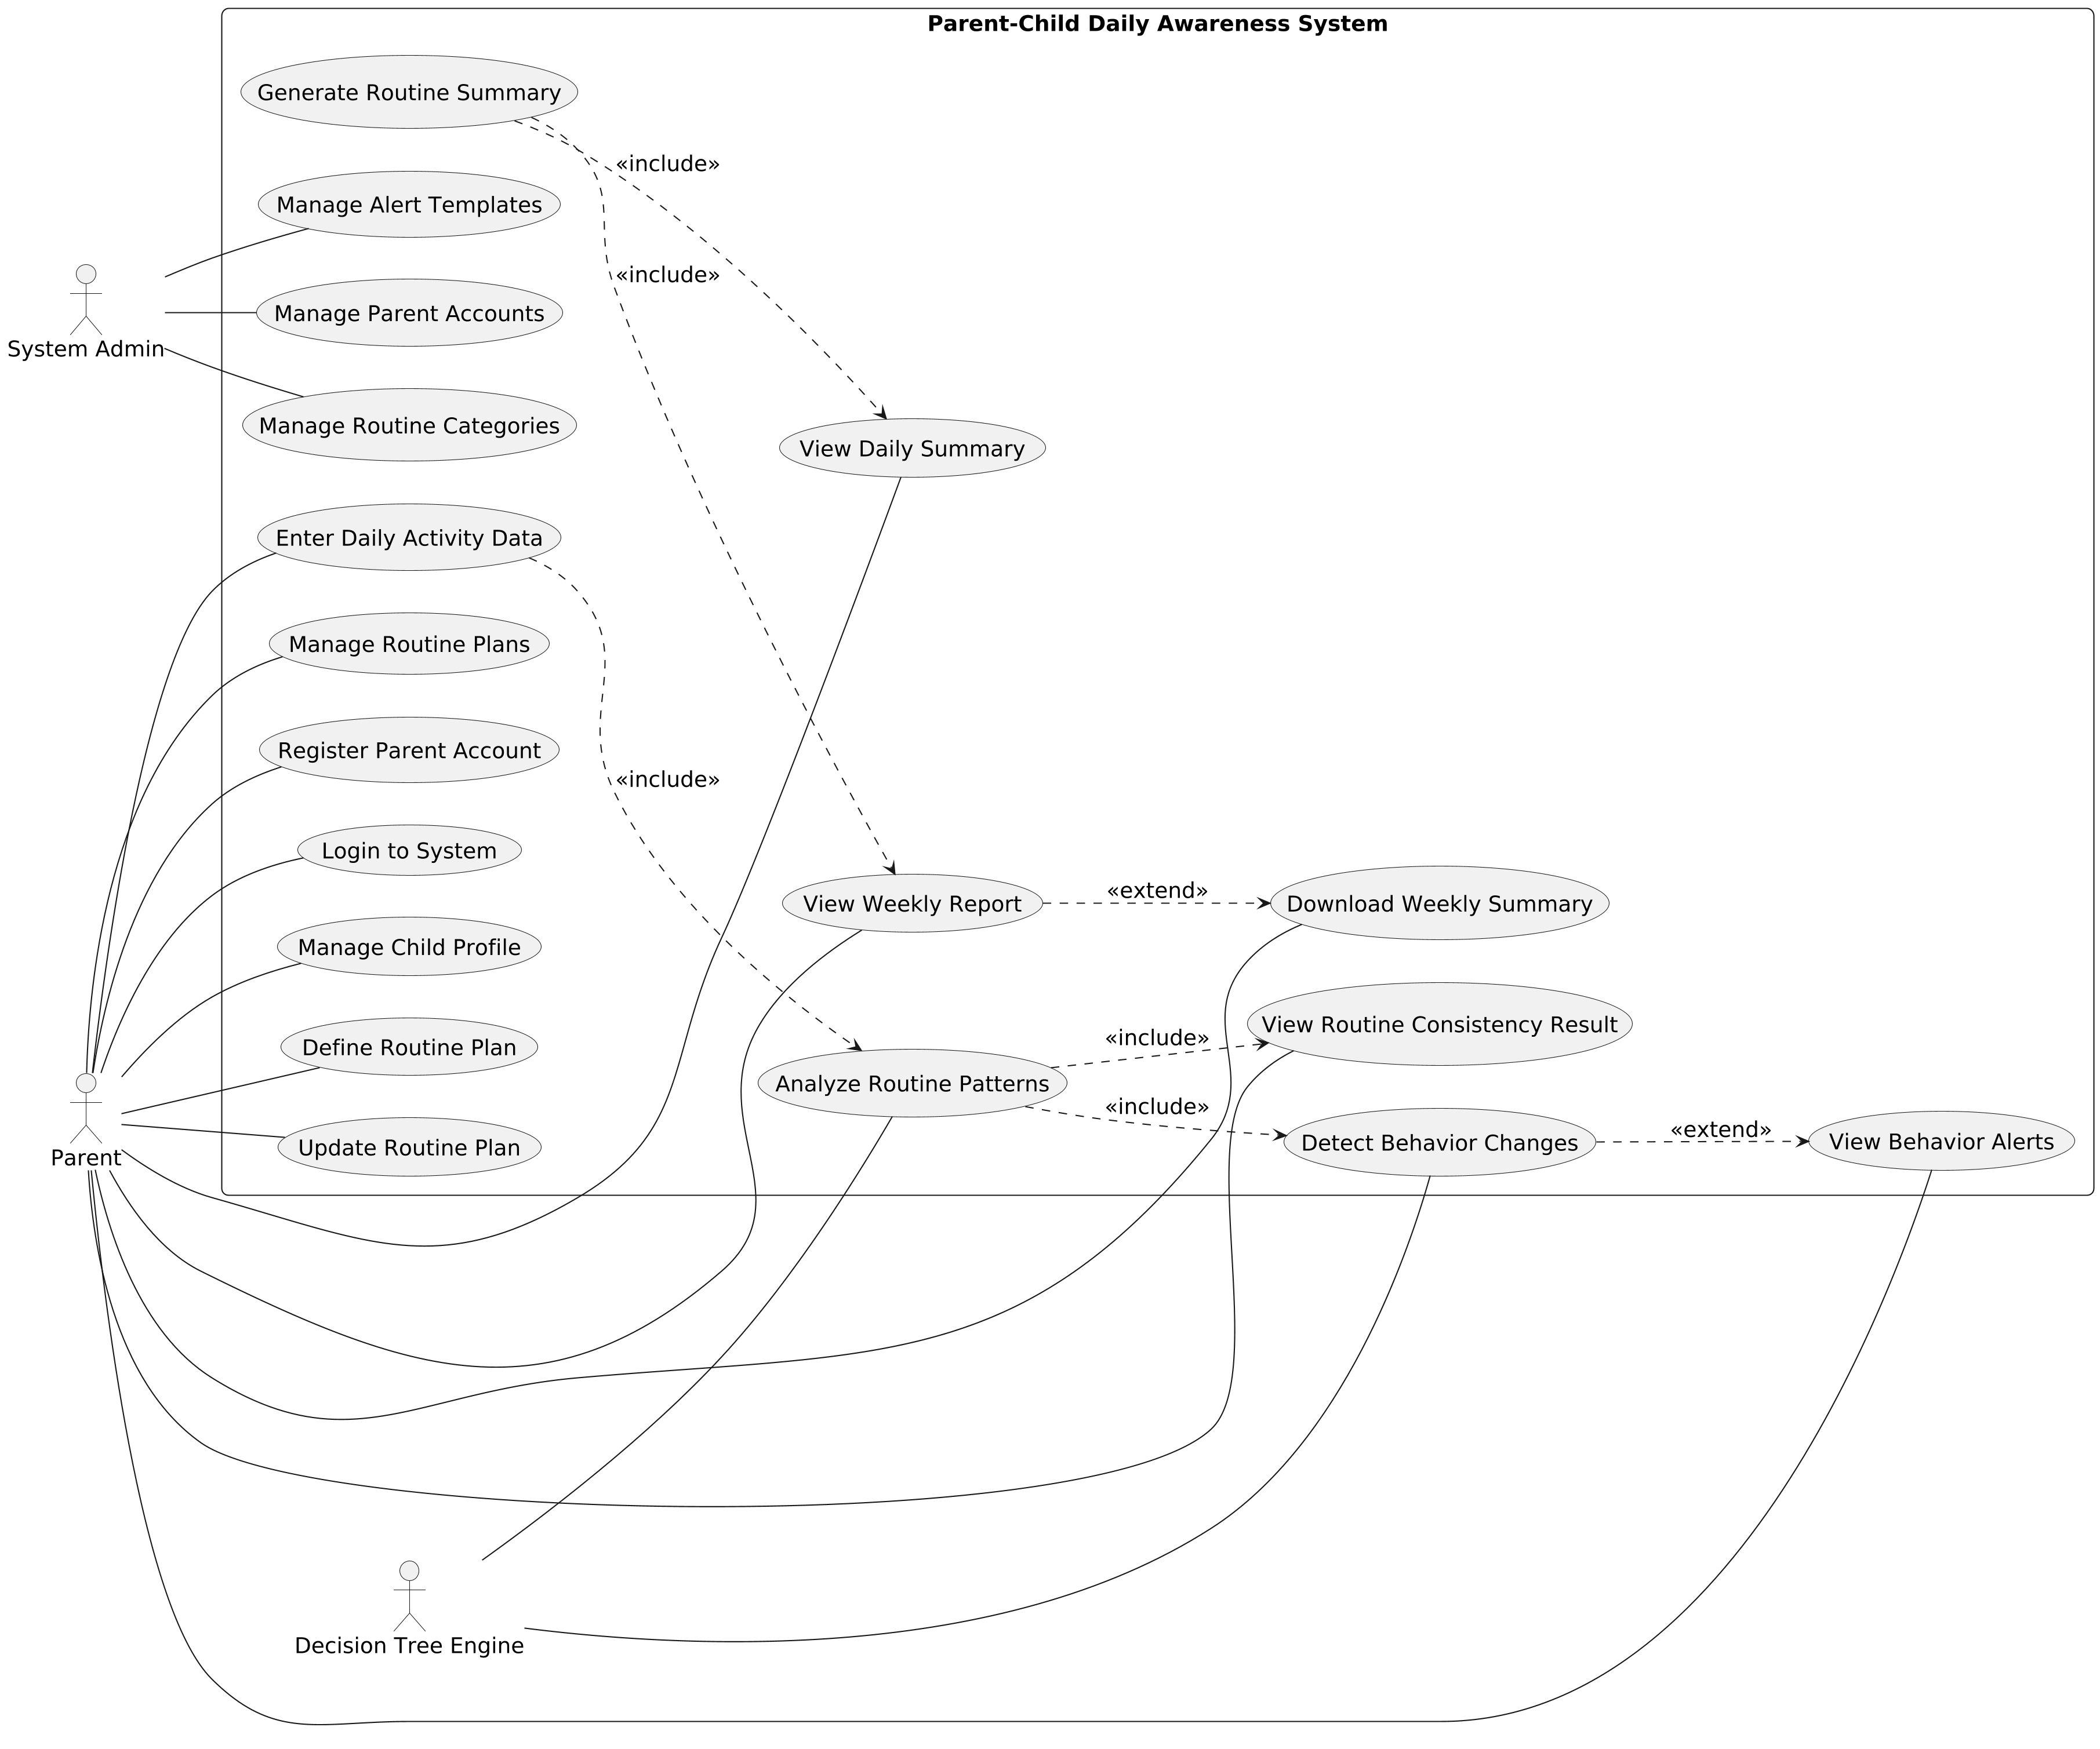
Figure.1 Use Case Diagram

2. Use Case Description
Use Case 1 – Register Parent Account
Use Case ID: UC-1
Use Case Name: Register Parent Account
Primary Actor: Parent
Stakeholders & Interests:
- Parent: Wants to create a secure account to start using the system.
- System: Must store valid account details securely.
Brief Description:
This use case allows a parent to create a new account using an email address and password so they can access the Parent–Child Daily Awareness System.
Related Functional Requirement(s):
FR-1 (Parent can create account using email password)
Preconditions:
- Parent does not already have an existing account in the system.
Postconditions (Success Guarantee):
- A new parent account is created and stored successfully.
Trigger:
- Parent selects the “Register” option on the home page.
Main Success Scenario:
- Parent opens the registration page.
- Parent enters a valid email address and password.
- System validates the input values.
- System creates the parent account and stores the credentials securely.
- System displays a confirmation message indicating successful registration.
Extensions (Alternate / Exception Flows):
- 3a. Email already exists → System displays an error message and requests a different email address.
- 3b. Invalid email format or weak password → System prompts the parent to correct the input.

Use Case 2 – Login to System
Use Case ID: UC-2
Use Case Name: Login to System
Primary Actor: Parent
Stakeholders & Interests:
- Parent: Wants to securely access the system to manage routines and view summaries.
- System: Must authenticate users and protect access to private data.
Brief Description:
This use case allows a registered parent to sign in to the Parent–Child Daily Awareness System using saved credentials to access their dashboard and features.
Related Functional Requirement(s):
2 (Parent can sign in using saved credentials)
Preconditions:
- Parent account already exists in the system.
Postconditions (Success Guarantee):
- Parent is successfully authenticated and redirected to the main dashboard.
Trigger:
- Parent selects the “Login” option on the home page.
Main Success Scenario:
- Parent opens the login page.
- Parent enters registered email and password.
- System validates the credentials.
- System grants access and displays the main dashboard.
Extensions (Alternate / Exception Flows):
- 3a. Incorrect email or password → System displays an error message and requests re-entry.
- 3b. Account is deactivated → System informs the parent that access is restricted.

Use Case 3 – Manage Child Profile
Use Case ID: UC-3
Use Case Name: Manage Child Profile
Primary Actor: Parent
Stakeholders & Interests:
- Parent: Wants to create and update child profiles to manage routines accurately.
- System: Must store and maintain correct child profile information.
Brief Description:
This use case allows a parent to create a new child profile or update an existing one using basic labels such as age range and routine name.
Related Functional Requirement(s):
6, 7 (Parent can create child profile using basic labels; Parent can edit child profile labels)
Preconditions:
- Parent is logged in to the system.
Postconditions (Success Guarantee):
- Child profile information is created or updated and saved successfully.
Trigger:
- Parent selects the option to create or edit a child profile.
Main Success Scenario:
- Parent opens the child profile section.
- Parent enters or edits basic labels such as age range and routine name.
- System validates the entered information.
- System saves the child profile details.
- System displays a confirmation message.
Extensions (Alternate / Exception Flows):
- 2a. Required fields are missing → System prompts the parent to complete the missing information.
- 3a. Invalid values entered → System requests correction before saving.

Use Case 4 – Define Routine Plan
Use Case ID: UC-4
Use Case Name: Define Routine Plan
Primary Actor: Parent
Stakeholders & Interests:
- Parent: Wants to define daily routine targets to guide consistent habits.
- System: Must store routine targets correctly for future comparison.
Brief Description:
This use case allows a parent to define routine targets for study time, sleep duration, screen usage, and spending range for a selected child profile.
Related Functional Requirement(s):
8, 9, 10, 11
Preconditions:
- Parent is logged in.
- Child profile already exists.
Postconditions (Success Guarantee):
- Routine targets are saved successfully for the selected child.
Trigger:
- Parent selects the option to define a new routine plan.
Main Success Scenario:
- Parent opens the routine plan section.
- Parent enters daily study target.
- Parent enters night sleep target range.
- Parent enters daily screen usage limit.
- Parent enters spending value band.
- System validates the entered values.
- System saves the routine plan.
- System displays a confirmation message.
Extensions (Alternate / Exception Flows):
- 6a. One or more values are invalid. The system displays validation errors and requests correction.

Use Case 5 – Update Routine Plan
Use Case ID: UC-5
Use Case Name: Update Routine Plan
Primary Actor: Parent
Stakeholders & Interests:
- Parent: Wants to adjust routine targets based on changing needs.
- System: Must update stored routine targets accurately.
Brief Description:
This use case allows a parent to modify existing routine targets for a saved routine plan.
Related Functional Requirement(s):
12
Preconditions:
- Parent is logged in.
- A routine plan already exists.
Postconditions (Success Guarantee):
- Routine targets are updated and saved successfully.
Trigger:
- Parent selects an existing routine plan to update.
Main Success Scenario:
- Parent opens an existing routine plan.
- Parent edits one or more routine target values.
- System validates the updated values.
- System updates the routine plan.
- System displays a confirmation message.
Extensions (Alternate / Exception Flows):
- 3a. One or more updated values are invalid. The system displays validation errors and requests correction.

Use Case 6 – Enter Daily Activity Data
Use Case ID: UC-6
Use Case Name: Enter Daily Activity Data
Primary Actor: Parent
Stakeholders & Interests:
- Parent: Wants to record daily routine data for tracking consistency.
- System: Must store daily activity values for analysis and reporting.
Brief Description:
This use case allows a parent to enter daily activity values for study time, sleep duration, screen time, and spending frequency for a child.
Related Functional Requirement(s):
13
Preconditions:
- Parent is logged in.
- A routine plan exists for the selected child.
Postconditions (Success Guarantee):
- Daily activity values are saved successfully.
Trigger:
- Parent opens the daily activity entry form.
Main Success Scenario:
- Parent opens the daily activity form.
- Parent enters study time, sleep duration, screen time, and spending frequency.
- System validates the entered values.
- System stores the daily activity data.
- System displays a confirmation message.
Extensions (Alternate / Exception Flows):
- 2a. One or more required values are missing. The system prompts the parent to complete all required fields.

Use Case 7 – View Daily Routine Summary
Use Case ID: UC-7
Use Case Name: View Daily Routine Summary
Primary Actor: Parent
Stakeholders & Interests:
- Parent: Wants to see a daily snapshot of routine completion and time usage.
- System: Must retrieve and present daily summary information accurately.
Brief Description:
This use case allows a parent to view a daily summary of routine completion and time usage for a selected date.
Related Functional Requirement(s):
14
Preconditions:
- Parent is logged in.
- Daily activity data exists for the selected date.
Postconditions (Success Guarantee):
- Daily routine summary is displayed.
Trigger:
- Parent selects the daily summary option.
Main Success Scenario:
- Parent selects a date to view the daily summary.
- System retrieves the daily activity data.
- System displays the daily routine snapshot.
Extensions (Alternate / Exception Flows):
- 2a. No data exists for the selected date. The system displays a message indicating no data is available.

Use Case 8 – View Weekly Routine Report
Use Case ID: UC-8
Use Case Name: View Weekly Routine Report
Primary Actor: Parent
Stakeholders & Interests:
- Parent: Wants to review weekly routine consistency trends.
- System: Must generate and present weekly reports accurately.
Brief Description:
This use case allows a parent to view a weekly routine consistency chart based on recorded daily activity data.
Related Functional Requirement(s):
15
Preconditions:
- Parent is logged in.
- Sufficient daily activity data exists for the selected week.
Postconditions (Success Guarantee):
- Weekly routine consistency chart is displayed.
Trigger:
- Parent selects the weekly report option.
Main Success Scenario:
- Parent selects a week to view the report.
- System aggregates daily activity data for the selected week.
- System generates the weekly routine consistency chart.
- System displays the weekly report.
Extensions (Alternate / Exception Flows):
- 2a. Insufficient data exists for the selected week. The system displays a message indicating limited data.

Use Case 9 – View Behavior Alerts
Use Case ID: UC-9
Use Case Name: View Behavior Alerts
Primary Actor: Parent
Stakeholders & Interests:
- Parent: Wants to be notified when unusual behavior changes are detected.
- System: Must present alerts clearly and only when significant deviations occur.
Brief Description:
This use case allows a parent to view alert messages when unusual behavior shifts are detected in routine patterns.
Related Functional Requirement(s):
16, 17
Preconditions:
- Parent is logged in.
- At least one behavior alert exists.
Postconditions (Success Guarantee):
- Alert message is displayed to the parent.
Trigger:
- The system generates an alert or the parent opens the alerts section.
Main Success Scenario:
- System identifies an unusual behavior shift.
- System generates an alert message.
- Parent opens the alerts section.
- System displays the alert message.
Extensions (Alternate / Exception Flows):
- 1a. No unusual behavior is detected. The system does not generate an alert.

Use Case 10 – View Routine Consistency Result
Use Case ID: UC-10
Use Case Name: View Routine Consistency Result
Primary Actor: Parent
Stakeholders & Interests:
- Parent: Wants to understand the routine consistency level and explanation.
- System: Must display analysis results clearly and accurately.
Brief Description:
This use case allows a parent to view the routine consistency level and explanation text produced by the system based on recorded activity data.
Related Functional Requirement(s):
18, 19
Preconditions:
- Parent is logged in.
- Routine analysis has been completed by the system.
Postconditions (Success Guarantee):
- Routine consistency level and explanation are displayed.
Trigger:
- Parent selects the routine consistency result option.
Main Success Scenario:
- Parent opens the routine consistency view.
- System retrieves the analysis result.
- System displays the consistency level and explanation text.
Extensions (Alternate / Exception Flows):
- 2a. Analysis results are not yet available. The system displays a processing message.

Use Case 11 – Filter Summaries by Date Range
Use Case ID: UC-11
Use Case Name: Filter Summaries by Date Range
Primary Actor: Parent
Stakeholders & Interests:
- Parent: Wants to view summaries for specific dates to review patterns.
- System: Must filter and display summary data accurately.
Brief Description:
This use case allows a parent to filter daily and weekly summaries by selecting a specific date range.
Related Functional Requirement(s):
20
Preconditions:
- Parent is logged in.
- Summary data exists.
Postconditions (Success Guarantee):
- Filtered summaries are displayed.
Trigger:
- Parent selects the date range filter option.
Main Success Scenario:
- Parent selects a start date and end date.
- System validates the selected date range.
- System filters the summary data based on the selected range.
- System displays the filtered summaries.
Extensions (Alternate / Exception Flows):
- 2a. Invalid date range selected. The system displays an error and requests correction.

Use Case 12 – Download Weekly Summary
Use Case ID: UC-12
Use Case Name: Download Weekly Summary
Primary Actor: Parent
Stakeholders & Interests:
- Parent: Wants to download the weekly overview for offline review.
- System: Must generate and provide a downloadable file.
Brief Description:
This use case allows a parent to download the weekly routine overview as a PDF file.
Related Functional Requirement(s):
21
Preconditions:
- Parent is logged in.
- Weekly report is available.
Postconditions (Success Guarantee):
- Weekly summary is downloaded as a PDF file.
Trigger:
- Parent selects the download option from the weekly report view.
Main Success Scenario:
- Parent selects the download option.
- System generates the weekly overview in PDF format.
- System provides the file for download.
- Parent downloads the file.
Extensions (Alternate / Exception Flows):
- 2a. PDF generation fails. The system displays an error message.

Use Case 13 – Review Routine Target Change History
Use Case ID: UC-13
Use Case Name: Review Routine Target Change History
Primary Actor: Parent
Stakeholders & Interests:
- Parent: Wants to review past changes made to routine targets.
- System: Must maintain and display an accurate history of changes.
Brief Description:
This use case allows a parent to view the history of changes made to routine targets over time.
Related Functional Requirement(s):
22
Preconditions:
- Parent is logged in.
- At least one routine target change exists.
Postconditions (Success Guarantee):
- Routine target change history is displayed.
Trigger:
- Parent selects the routine change history option.
Main Success Scenario:
- Parent opens the change history section.
- System retrieves the routine target change history.
- System displays the list of changes.
Extensions (Alternate / Exception Flows):
- 2a. No change history exists. The system displays a message indicating no history is available.

Use Case 14 – Add Observation Note
Use Case ID: UC-14
Use Case Name: Add Observation Note
Primary Actor: Parent
Stakeholders & Interests:
- Parent: Wants to add personal notes to summaries for future reference.
- System: Must save and associate notes with the correct summary.
Brief Description:
This use case allows a parent to add an observation note to a daily or weekly summary.
Related Functional Requirement(s):
23
Preconditions:
- Parent is logged in.
- A daily or weekly summary exists.
Postconditions (Success Guarantee):
- Observation note is saved with the selected summary.
Trigger:
- Parent selects the option to add a note to a summary.
Main Success Scenario:
- Parent opens a summary.
- Parent enters an observation note.
- System saves the note with the summary.
- System displays a confirmation message.
Extensions (Alternate / Exception Flows):
- 2a. Observation note is empty. The system displays an error and requests valid input.

Use Case 15 – Manage Routine Plan Archive
Use Case ID: UC-15
Use Case Name: Manage Routine Plan Archive
Primary Actor: Parent
Stakeholders & Interests:
- Parent: Wants to archive older routine plans and restore them when needed.
- System: Must maintain archived plans and allow restoration.
Brief Description:
This use case allows a parent to archive older routine plans or restore previously archived plans.
Related Functional Requirement(s):
24, 25
Preconditions:
- Parent is logged in.
- At least one routine plan exists.
Postconditions (Success Guarantee):
- Selected routine plan is archived or restored successfully.
Trigger:
- Parent selects the archive or restore option for a routine plan.
Main Success Scenario:
- Parent views the list of routine plans.
- Parent selects a routine plan.
- Parent chooses to archive or restore the selected plan.
- System updates the plan status.
- System displays a confirmation message.
Extensions (Alternate / Exception Flows):
- 2a. Selected routine plan is not found. The system displays an error message.

Use Case 16 – Manage Parent Accounts
Use Case ID: UC-16
Use Case Name: Manage Parent Accounts
Primary Actor: System Admin
Stakeholders & Interests:
- System Admin: Wants to control access to parent accounts.
- System: Must update account status accurately.
Brief Description:
This use case allows a system administrator to view parent accounts and activate or deactivate account access.
Related Functional Requirement(s):
26, 27, 28, 29
Preconditions:
- System Admin is logged in.
Postconditions (Success Guarantee):
- Selected parent account status is updated.
Trigger:
- System Admin selects the parent account management option.
Main Success Scenario:
- System Admin views the list of registered parent accounts.
- System Admin selects a parent account.
- System Admin activates or deactivates the selected account.
- System saves the updated account status.
- System displays a confirmation message.
Extensions (Alternate / Exception Flows):
- 2a. Selected parent account is not found. The system displays an error message.

Use Case 17 – Manage Routine Categories
Use Case ID: UC-17
Use Case Name: Manage Routine Categories
Primary Actor: System Admin
Stakeholders & Interests:
- System Admin: Wants to maintain routine categories used in the system.
- System: Must store and update routine categories accurately.
Brief Description:
This use case allows a system administrator to view, create, update, and remove routine categories.
Related Functional Requirement(s):
30, 31, 32, 33
Preconditions:
- System Admin is logged in.
Postconditions (Success Guarantee):
- Routine categories are created, updated, or removed successfully.
Trigger:
- System Admin selects the routine category management option.
Main Success Scenario:
- System Admin views the routine category list.
- System Admin creates, edits, or removes a routine category.
- System validates the category changes.
- System saves the updated routine categories.
- System displays a confirmation message.
Extensions (Alternate / Exception Flows):
- 2a. Duplicate category label entered. The system displays an error and requests a different label.

Use Case 18 – Manage Alert Templates
Use Case ID: UC-18
Use Case Name: Manage Alert Templates
Primary Actor: System Admin
Stakeholders & Interests:
- System Admin: Wants to configure alert message templates.
- System: Must store and apply updated alert templates.
Brief Description:
This use case allows a system administrator to view and update alert message templates used for behavior notifications.
Related Functional Requirement(s):
34, 35
Preconditions:
- System Admin is logged in.
Postconditions (Success Guarantee):
- Alert templates are updated and saved successfully.
Trigger:
- System Admin selects the alert template management option.
Main Success Scenario:
- System Admin views current alert configuration settings.
- System Admin edits alert message templates.
- System validates the updated templates.
- System saves the changes.
- System displays a confirmation message.
Extensions (Alternate / Exception Flows):
- 2a. Alert template content is empty. The system displays an error and requests valid input.

3. Activity Diagram
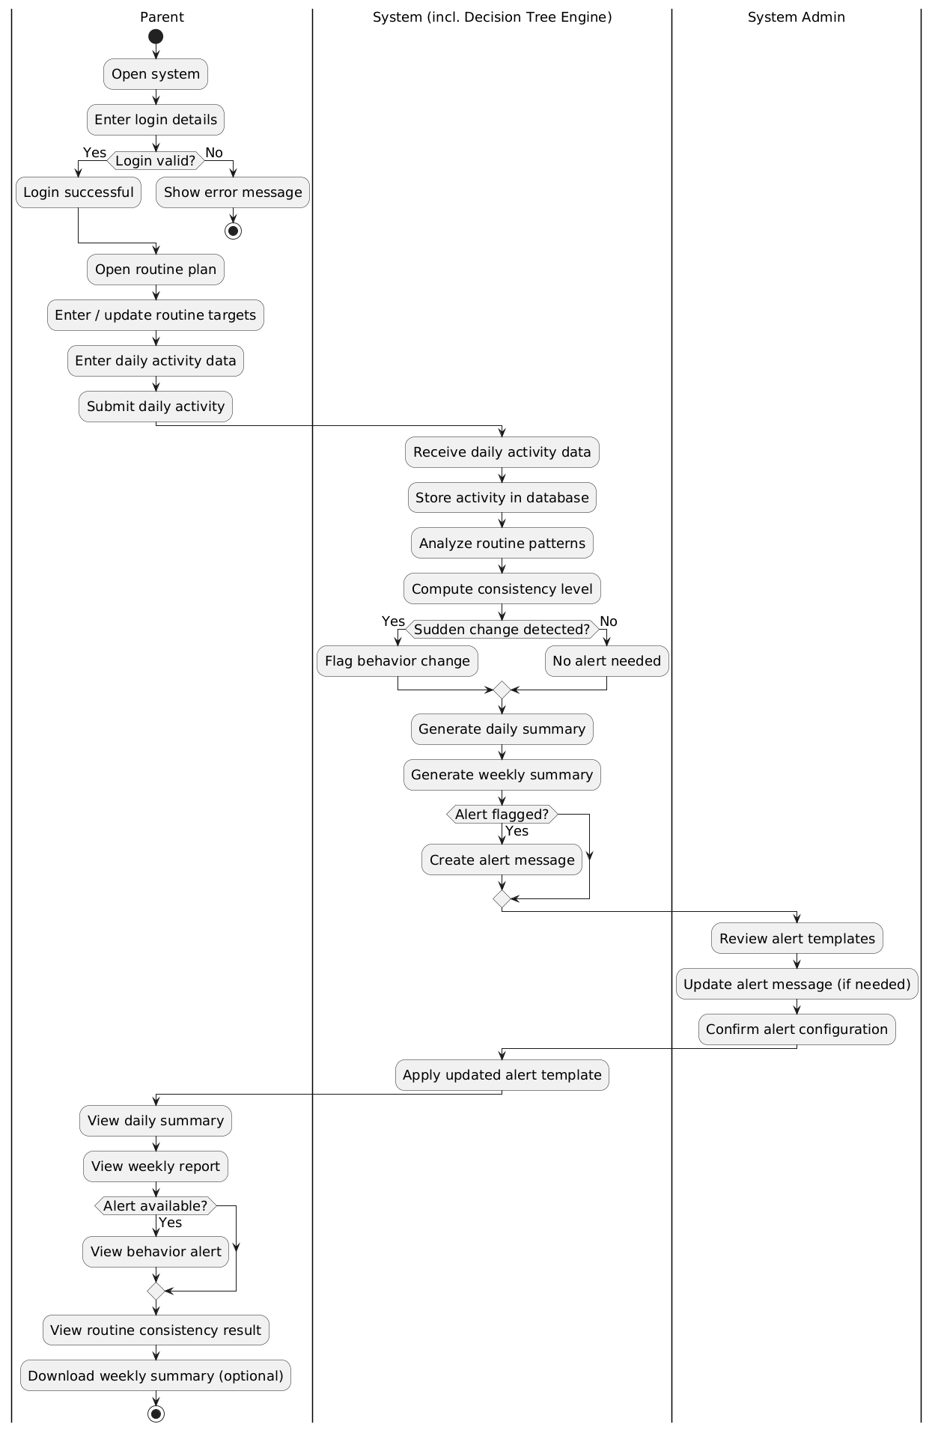
Figure.2 Activity Diagram

